People are always get tricked by data visualization in today’s time in every aspect like issues of political background to statistics of every sport. In the recent report that every ROI of a company blog, the internet and reports are flooded with several examples of misleading data visualization.

To handle this misleading information is to arm yourself with tech-appropriate analytical and evaluative skills that will expose the most oversimplified and malicious data visualizations. There are few features that will present some most common data misrepresentations.

**Truncated y-axis:**

This truncated y-axis is a classic way to visually mislead. Look at the graph below, the conventional way of organizing the y-axis is to start with 0 and then go up the highest data point in your set. By not setting the origin of the y axis at zero, small differences become hyperbolic.

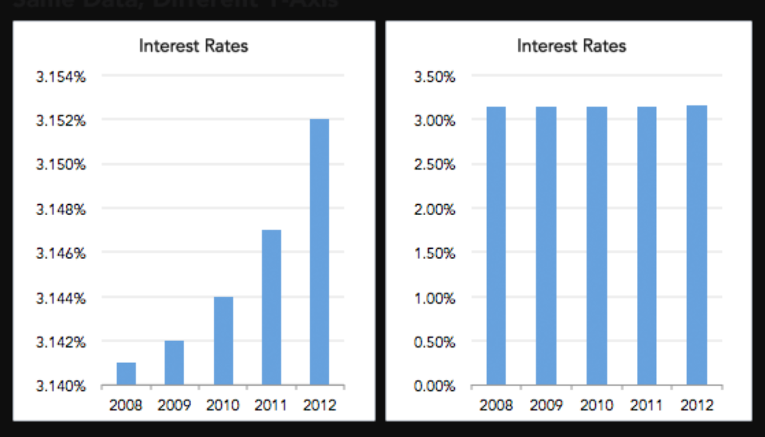

**Omitting Data:**

By omitting certain data points, trends that do not actually exist can easily be created whereas some existing highlights can go unnoticed. That is because by omitting some data we are missing the context. Leaving out variables can affect how you interpret the data and what conclusions you draw from it. So, whenever you are examining a variable and its relationships, carefully consider the context in which that variable exists and deliberately seek out other variables that could affect the one you’re studying.

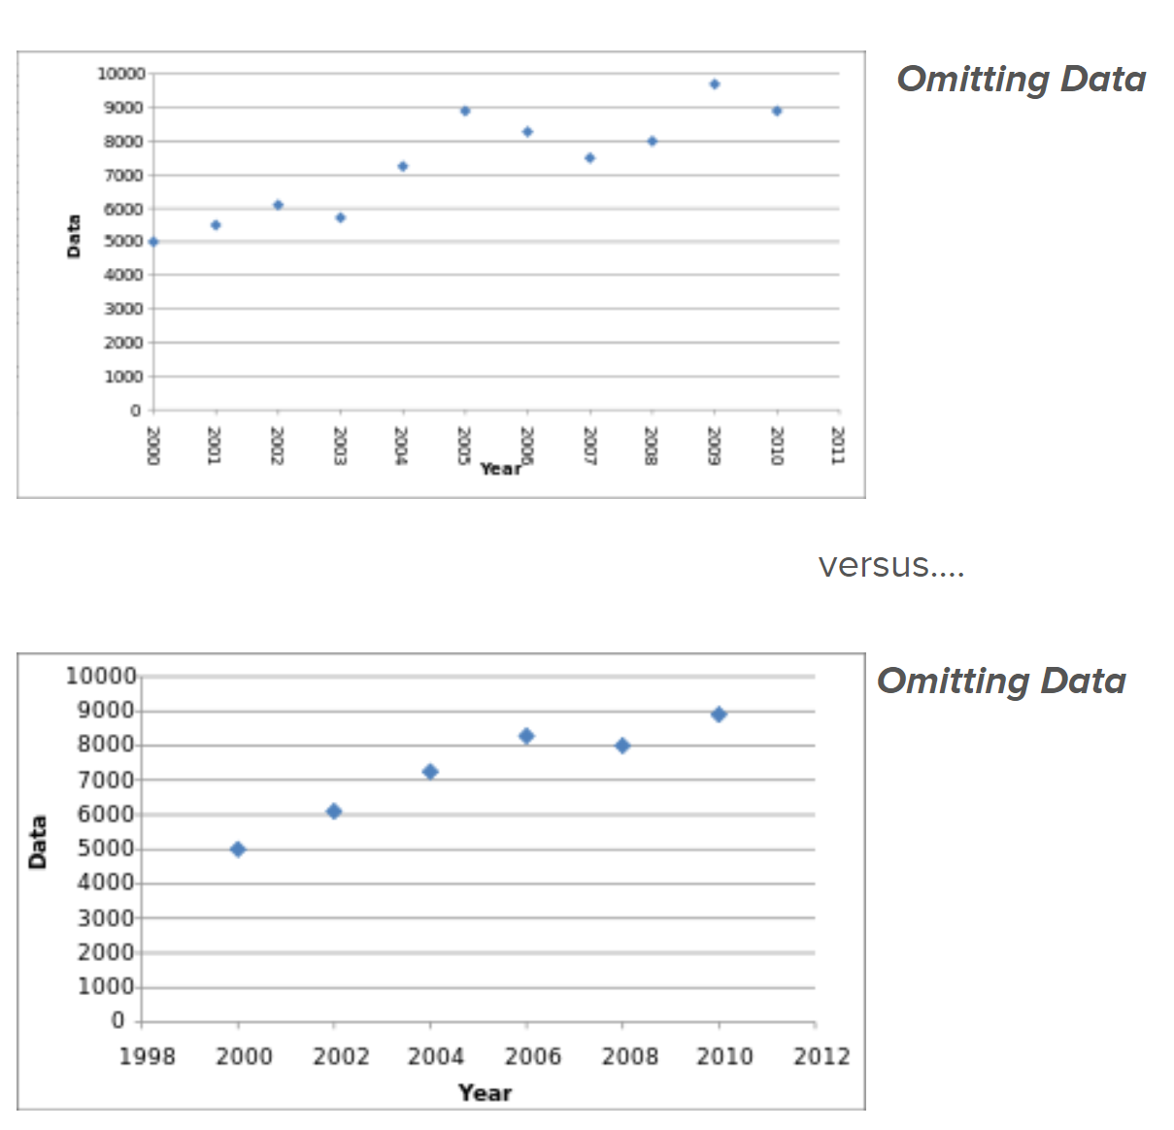

**References:**

1. <https://www.datapine.com/blog/misleading-data-visualization-examples/>